Transregional Collaborative Research Center 127
Biology of Xenogeneic Cell, Tissue and Organ Transplantation –
From Bench to Bedside
Final Meeting 14.-17.05.2024

Venice International University
San Servolo, Venice, IT
https://www.univiu.org/

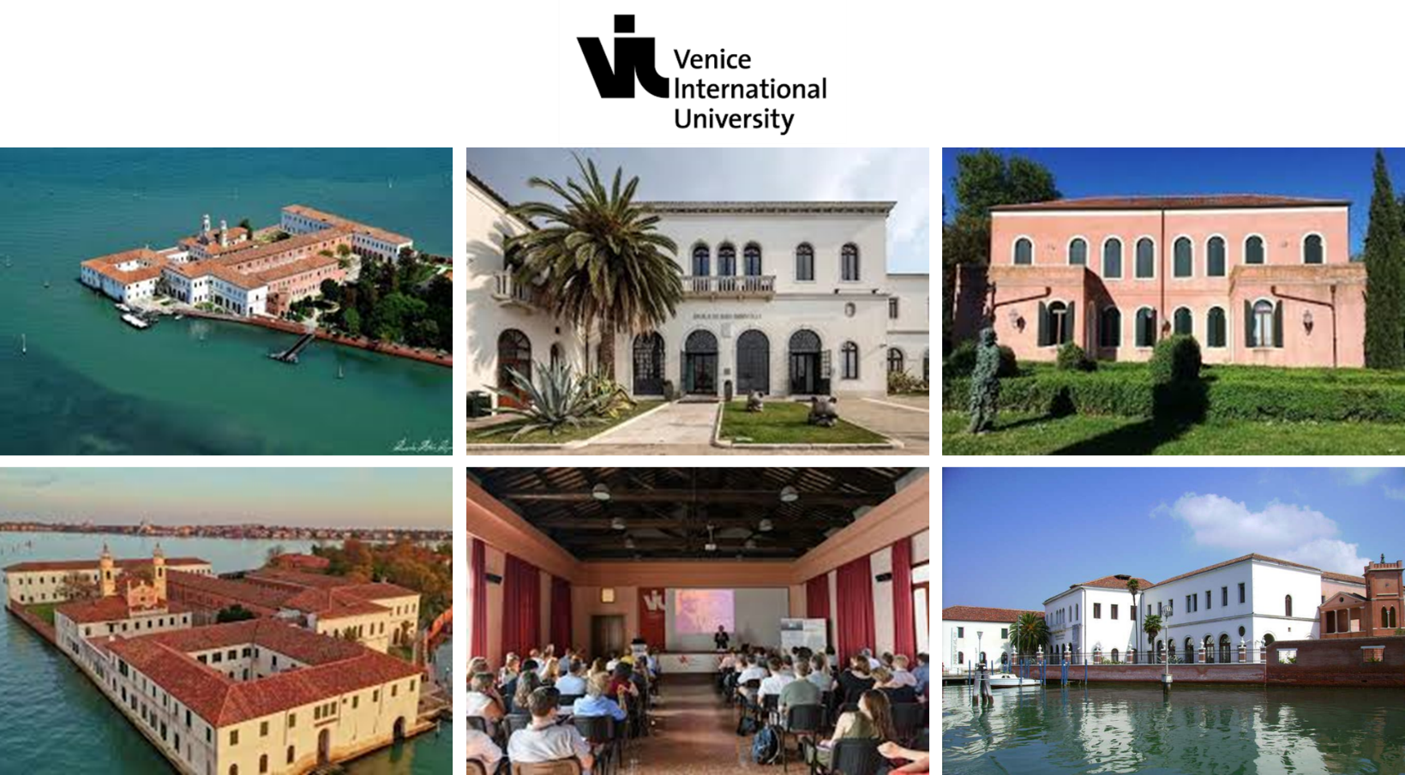

Tuesday, 14.05.2025
18.30 | G E T T O G E T H E R
18.45 | Welcome and Introduction - Bruno Reichart, Eckhard Wolf
19.00 | D I N N E R – with members of the Leducq Excellence Network

Wednesday, 15.05.2024
Modulating the host-to-xenograft immune response
08.30 | Targeting stimulatory and inhibitory receptor/ligand interactions to diminish human anti-pig immune responses  Reinhard Schwinzer, Constanca Ferreira de Figueiredo (A1)
09.00 | Local immunomodulation by viral vectors and genetic modifications  Andrea Bähr, Sebastian Michel, Peter Murray, Christian Kupatt (A2)
09.30 | Immunogenicity of islets of different clinically relevant sources in a preclinical humanized mouse model  Claudia Waskow, Barbara Ludwig, Andreas Linkermann (A5)
10.00 | Regulatory T cells in xenotransplantation  Elmar Jaeckel, Fatih Noyan (A4)
10.30 | C O F F E E
11.00 | Immunity, macrophage: T cell cross-talk, self-tolerance, amino acid metabolism  Peter Murray, Max Planck Institute of Biochemistry, Munich
11.30 | snRNA-seq and spatial transcriptomics to provide new insights into xenotransplant rejection mechanisms  Daniel Reichart, Department of Cardiology, LMU Klinikum, and Gene Center, LMU Munich
12.00 | N.N.  Joshua I. Weiner, Columbia University, Department of Surgery
12.30 | L U N C H
Optimizing source pigs for xenotransplantation
14.00 | Modifying the porcine genome for xeno-organ transplantation  Konrad Fischer, Wilfried Kues (B1&2)
14.30 | Auckland Island pigs – new source for xenogeneic organ transplantation  Asghar Ali, Gene Center, LMU Munich
14.40 | Genetically engineered donor pigs with improved pancreatic islets  Elisabeth Kemter, Anika Böttcher, Nikolai Klymiuk, Eckhard Wolf (B2)
15.00 | Genetic analysis of PERV  Nikolai Klymiuk (B2)
15.20 | Microbiological including virologic safety  Antonia W. Godehardt, Ralf R. Tönjes, Joachim Denner, Benedikt B. Kaufer
16.00 | C O F F E E
Exogenesis – cellular humanization of porcine organs
16.30 | Engineering humanized vasculature in a gene edited pig  Daniel J. Garry, University of Minnesota
17.00 | Exogenous organs for transplantation without rejection  Hiromitsu Nakauchi, Stanford University and Tokyo Medical and Dental University
17.30 | Overcoming xeno-barriers in human-animal chimera formation  Hideki Makaki, Tokyo Medical and Dental University
18.00 | Recapitulating porcine cardiac development in vitro: from expanded potential stem cell to embryo culture models  Monika Nowak-Imialek, Technical University of Munich
19.00 | D I N N E R

Thursday, 16.05.2024
Xenogeneic and allogeneic beta-cell replacement strategies
08.30 | Comparative developmental biology of murine, porcine and human islets  Heiko Lickert, Helmholtz Munich
09.00 | Optimization of porcine neonatal islet like cell clusters for clinical transplantation therapy  Stephan Speier, Christian Cohrs, Elisabeth Kemter (C1)
09.30 | Treatment of type 1 diabetes with porcine islet cells: transplantation of multi-transgenic islets expressing immunomodulatory molecules  Lelia Wolf-van Buerck, Jochen Seissler (C3)
10.00 | Optimizing porcine islet macroencapsulation for the treatment of patients with insulin-dependent diabetes mellitus  Barbara Ludwig, Stefan Bornstein, Rocio Sancho Zapatero, Petra Welzel (C4)
10.30 | C O F F E E
Gene and cell therapies of cardiac and skeletal muscle
11.00 | Humanized skeletal muscle in pig  Mary G. Garry, University of Minnesota
11.30 | Gene therapy of Duchenne muscular dystrophy  Christian Kupatt, Technical University of Munich
12.00 | Designer cells for cardiac regeneration  Alessandra Moretti, Technical University of Munich
12.30 | L U N C H
Xenotransplantation of heart valves and hearts
14.00 | Preclinical assessment of antigen-reduced decellularized porcine heart valves  Andres Hilfiker, Serghei Cebotari, Falk Büttner, Heiner Niemann
14.30 | Steps to clinical xenogeneic cardiac replacement  Matthias Längin, Jan-Michael Abicht, Paolo Brenner, Bruno Reichart
15.00 | Cardiac xenotransplantation in humans  Muhammad M. Mohiuddin, University of Maryland School of Medicine
16.00 | C O F F E E
Ethical, legal and societal implications
16.30 | Ethical, legal, psychosocial, and societal issues of xenotransplantation and exogenesis  Georg Marckmann, Jochen Sautermeister, Nils Hoppe
17.45 | Finances and reporting  Dorothea Marquardt, Eckhard Wolf
18.00 | Views back and views ahead  Bruno Reichart, Eckhard Wolf
19.00 | D I N N E R

Friday, 17.05.2024
09.00 | Venice Tour
12.30 | L U N C H
13.30 | End of the Meeting

