Transregio Collaborative Research Centre 127 of the German Research Society (DFG) and the 18thMinisymposium Xenotransplantation of the German Working Group Xenotransplantation (DAX)

Program

September 28 - 30, 2015, Freising, Kardinal Döpfner Haus

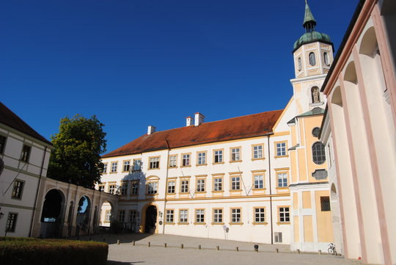

**Monday, September 28, 2015**

9 a.m. – 6 p.m.

Work shop

Young Investigator Program

3 – 6 p.m.

Board Meeting

6 – 6.45 p.m.

Poster presentation to the board

7 p.m.

Board member dinner and decision about young investigators

**Tuesday, September 29, 2015**

***SFB TRR 127***

***Internal debate on the forthcoming extension***

8.00 a.m. – 8.15 a.m.

*Opening*

8.15 a.m.

A 1

*Reinhard Schwinzer, Constanca de Figueiredo*

8.35 a.m.

A 2

*Rabea Hinkel, Christian Kupatt*

8.55 a.m.

A 4

*Elmar Jaeckel*

9.15 a.m.

A 5

*Claudia Waskow, Barbara Ludwig, Nicolai Klymiuk*

9.35 a.m.

A 6

*Joachim Denner, Ralf Tönjes*

**9.55- 10.20 a.m.**

***Coffee break***

10.20 a.m.

B 1

*Heiner Niemann, Wilfried Kues, Andrea Lucas-Hahn*

10.40 a.m.

B 2

*Angelika Schnieke, Tatiana Flisikowska, Percy Knolle*

11.00 a.m.

B 3

*Eckhard Wolf, Nicolai Klymiuk, Elisabeth Kemter, Annegret Wünsch*

11.20 a.m.

Z 2

*Joachim Denner, Ralf Tönjes, Heiner Niemann, Angelika Schnieke, Eckhard Wolf*

11.40 a.m.

C 1

*Stephan Speier, Anthony Gavalas, Elisabeth Kemter*

12 a.m.

C 2

*Michele Solimena, Eckhard Wolf*

**12.20 p.m.**

***Get together and lunch break***

1.20 p.m.

C 3

*Jochen Seissler, Lelia Wolf von Bürck*

1.40 p.m.

C 4

*Stefan Bornstein, Barbara Ludwig*

2 p.m.

C 5

*Paolo Brenner, Jan-Michael Abicht, Bruno Reichart, Stefan Buchholz*

2.20 p.m.

C 6

*Andreas Tiede, Sonja Werwitzke, Wolf Ramackers*

2.40 p.m.

C 7

*Andres Hilfiker, Axel Haverich*

3 p.m.

Z 1

*Georg Marckmann, Jochen Sautermeister, Nils Hoppe*

**3.30 – 3.50 p.m.**

***Coffee break***

3.50 p.m.

A 3

*Triantafyllos Chavakis*

4.10 p.m.

Z 3

*Franz-Josef Kaup*

4.30 p.m.

Concluding discussion

5.50 p.m.

*Islet Group, Stephan Speier*

7 p.m.

Casual dinner and welcome of our guests from King´s College London, UK

discussions

**Wednesday, September 30, 2015**

8.30 a.m. – 12.20 p.m.

Short presentation of the individual projects

8.30 a.m.

A1

*Reinhard Schwinzer, Constanca de Figueiredo*

8.40 a.m.

A 2

*Rabea Hinkel, Christian Kupatt*

8.50 a.m.

A 3

*Triantafyllos Chavakis*

9 a.m.

A 4

*Elmar Jaeckel*

9.10 a.m.

A 5

*Claudia Waskow, Barbara Ludwig, Nicolai Klymiuk*

9.20 a.m.

A 6

*Joachim Denner, Ralf Tönjes*

9.30 a.m.

B 1

*Heiner Niemann, Wilfried Kues, Andrea Lucas-Hahn*

9.40 a.m.

B 2

*Angelika Schnieke, Tatiana Flisikowska, Percy Knolle*

9.50 a.m.

B 3

*Eckhard Wolf, Nicolai Klymiuk, Elisabeth Kemter, Annegret Wünsch*

10 a.m.

Z 2

*Joachim Denner, Ralf Tönjes, Heiner Niemann, Angelika Schnieke, Eckhard Wolf*

**10.20 – 10.40 a.m.**

***Coffee break***

10.40 a.m.

C 1

*Stephan Speier, Anthony Gavalas, Elisabeth Kemter*

10.50 a.m.

C 2

*Michele Solimena, Eckhard Wolf*

11 a.m.

C 3

*Jochen Seissler, Lelia Wolf von Bürck*

11.10 a.m.

C 4

*Stefan Bornstein, Barbara Ludwig*

11.20 a.m.

C 5

*Paolo Brenner, Jan-Michael Abicht, Bruno Reichart, Stefan Buchholz*

11.30 a.m.

C 6

*Andreas Tiede, Sonja Werwitzke, Wolf Ramackers*

11.40 a.m.

C 7

*Andres Hilfiker, Axel Haverich*

11.50 a.m.

Z 1

*Georg Marckmann, Jochen Sautermeister, Nils Hoppe*

12.10 p.m.

Z 3

*Franz-Josef Kaup*

**12.20 – 1.15 p.m.**

***Lunch break***

1.15 p.m.

Presentations of our guests from King´s College, UK

3 p.m.

Official end of the meeting

**3 p.m. – 4.30 p.m.**

***Coffee break and discussions***