Supplementary methods:

SFTPC long PCR
DNA was extracted from 200 μL of EDTA-blood with Qiamp blood minikit (Qiagen, Milano, Italy).
Long PCR assay was performed with a 50 μL reaction volume containing 5 μL of distilled water, 100 ng of DNA, 5 μL of 10x PCR Tuning Buffer with Mg²⁺ (2 mM), 2.5 μL of dNTPs (10 mM each), 400 nM of each primers (SFTPCfor 5’-CCAGTGGGGACAGAGTTTCC-3’ and SFTPCrev 5’-TAGGGAAATGAGCTCGCTGG-3’), and 2 U of PCR extender polymerase (5 U/μL, PCR Extender System) (5PRIME, Hilden Deutschland). The PCR product size was 3978 bp.
The amplification conditions for the PCR reaction were as follow 1cycle of 93°C for 3 minute, 10 cycles of 93°C 15 seconds, 62°C for 30 seconds and 68°C for 8 minutes, 8 cycles of 93°C 15 seconds, 62°C 30 seconds and 68°C 8 min + 20 seconds every cycles.
SFTPA and SFTPB Sequencing.
We sequenced all the 5 exons of SFTPA gene and all the 10 exons of SFTPB gene. Amplicons were directly sequenced in an automatic genetic analyzer (CEQ 8800 Genetic Analyzer; Beckman-Coulter). Primers used are shown in table S1 and S2.

SFTPA Exon | Primer | Product size
1 | ACACTATGCCCATTTCCTGC | 219
 | GCTGGTCCTCTCTGCCTG
2-3 | TGACAGAGCACAGTGGGG | 759
 | TGTAACTGACTTCAGGGTCGC
4 | GCAGATGGCAAAACACCTG | 218
 | AGAATGAGGGGAATTTGTGG
5_1 | TCTGGTAGCAGAGACCCCAG | 688
 | GGTGCAGTGCTGGGAGAG
5_2 | ACTTCATTCCTCTGATGGGC | 670
 | AGAAAGCAGAGCCAGTGGTG
5_3 | GCCTAGGCCTCTAGGGTGAC | 733
 | GGCTCAGAGTCAGAGTTCATTTG

Table S1. Primer used for SFTPA gene sequencing.

SFTPB Exon | Primer | Product size
1 | CTGCCTAGGAGAGGGGAGGCT | 792
 | CTATGCCCCAGCCCCTACCCTG
2 | GAGCCCACCCAGCACCCTTC | 451
 | AGCACTGCTTTGTGCTAGGCAT
3-4 | CAGGCAGGAGGTGAGCTTGCAG | 639
 | AGCCTCCCCCACTCATGTGTCC
5-6 | GGTATGCGTGTGCTCCTGGGC | 618
 | GGCCGGCCTGAATAGGGGTG
7-8 | GCCTTGAACGGGCCCTGACC | 624
 | AGCTGGGTGCTGGGCAGAGA
9-10 | GGGAGCAGAAGGGCCTCCCAT | 802
 | AGGCCAGGACCACACGACAGGA

Table S2. Primer used for SFTPB gene sequencing.
Plasmids
The pEYFP-hABCA3-WT vector with YFP fused to the C-terminus of ABCA3 was kindly provided by Prof. A. Holzinger. The ABCA3-G964D point mutation was introduced in the pEYFP-hABCA3-WT vector using the QuickChange Site-directed mutagenesis kit (Stratagene) with the following primers: G964D-for 5’-GCGAGTACGACAGAACCGTCGTG-3’ and G964D-rev 5’-CACGACGGTTCTGTCGTACTCGC-3’.
Immunefluorescence
YFP is a yellow fluorescent protein which does not need to be stained. Therefore, only LAMP3 and calnexin were stained according to the material and methods.
Western immunoblot
YFP was detected with a mouse-anti-GFP antibody (Clontech) and the Novex WesternBreeze Immunodetection Kit (Invitrogen). All other antibodies and procedures were as described in the materials and methods.

Acknowledgement: The pEYFP-hABCA3-WT vector was kindly provided by Prof. A. Holzinger.
Supplementary Figures

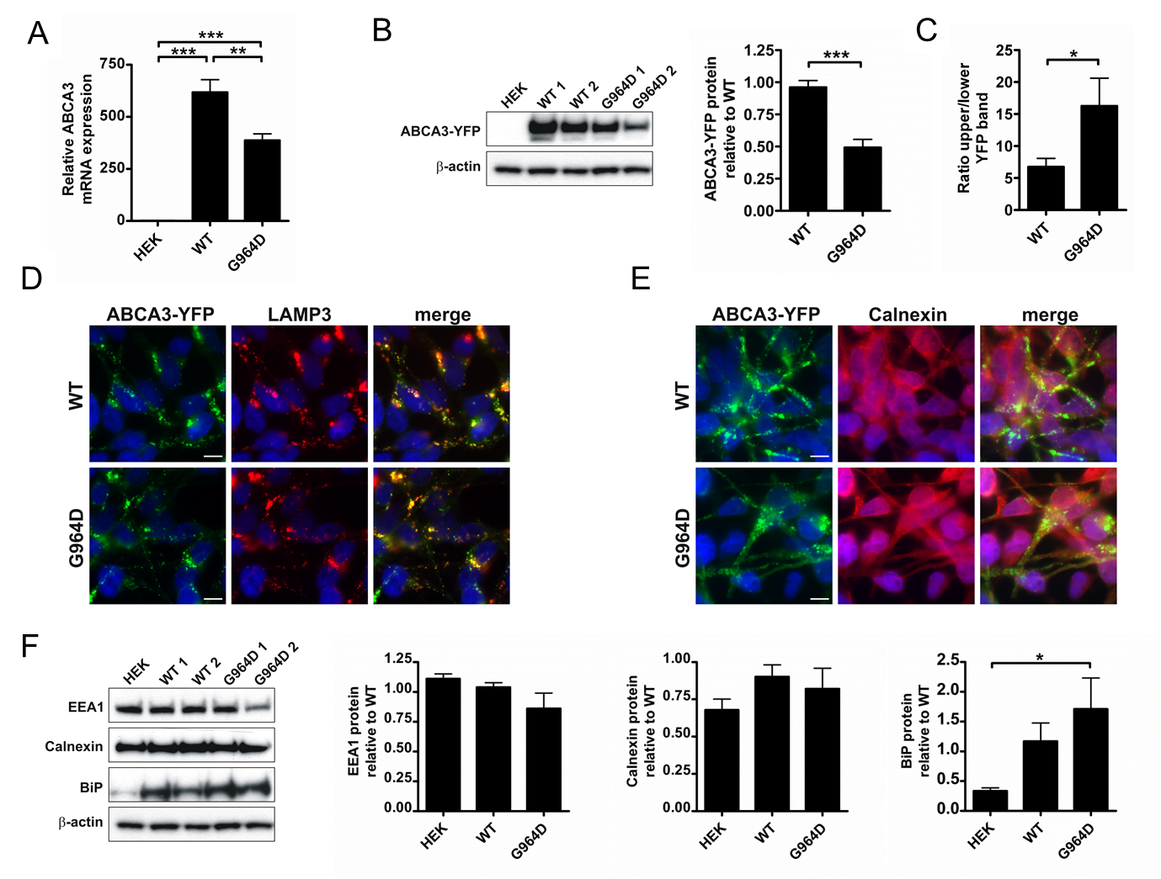

Figure S1. Cellular effects of stable ABCA3 expression in HEK cells.
A. ABCA3 mRNA expression levels analyzed by quantitative real time PCR. B. Western immunoblot analysis of YFP-tagged ABCA3 in total cell lysates. β-actin was used as a loading control. C. Ratio of the upper/lower ABCA3 processing form. D.Fluorescence of YFP-tagged ABCA3 and immunostaining of the lysosomal (lamellar body) marker LAMP3. E. Fluorescence of YFP-tagged ABCA3 and immunostaining of the ER marker calnexin. F. ER (calnexin, BiP) and early endosome markers (EEA1) in cells stably transfected with ABCA3. β-actin was used as a loading control. Scale bars: 7.5 µm, *P<0.05, **P<0.01, ***P<0.001.

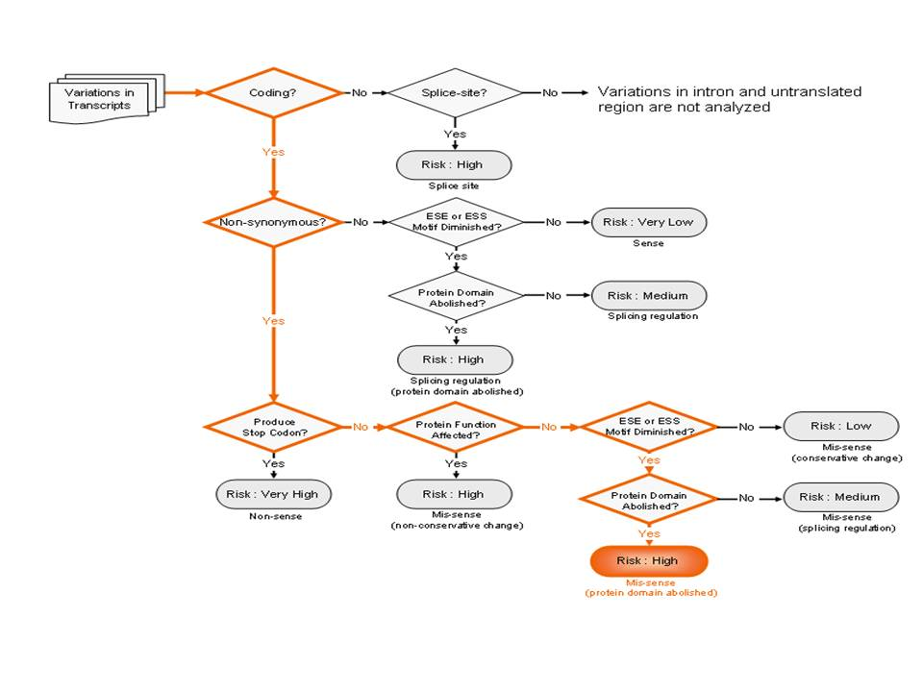
Figure S2. Bioinformatic analysis. Bioinformatic analysis of the ABCA3 G>A transition at nucleotide 2891 by FANS (Functional analysis of novel SNPs and mutations in human and mouse genomes) [12].

